STUDENT TRACKER MANAGEMENT SYSTEM
CREATED BY ( Sadia Uzma Ashrafi, Tuhin Roy, Saniya Mumtaz)
1. BASIC SELECT:
-- Reference concept: SELECT
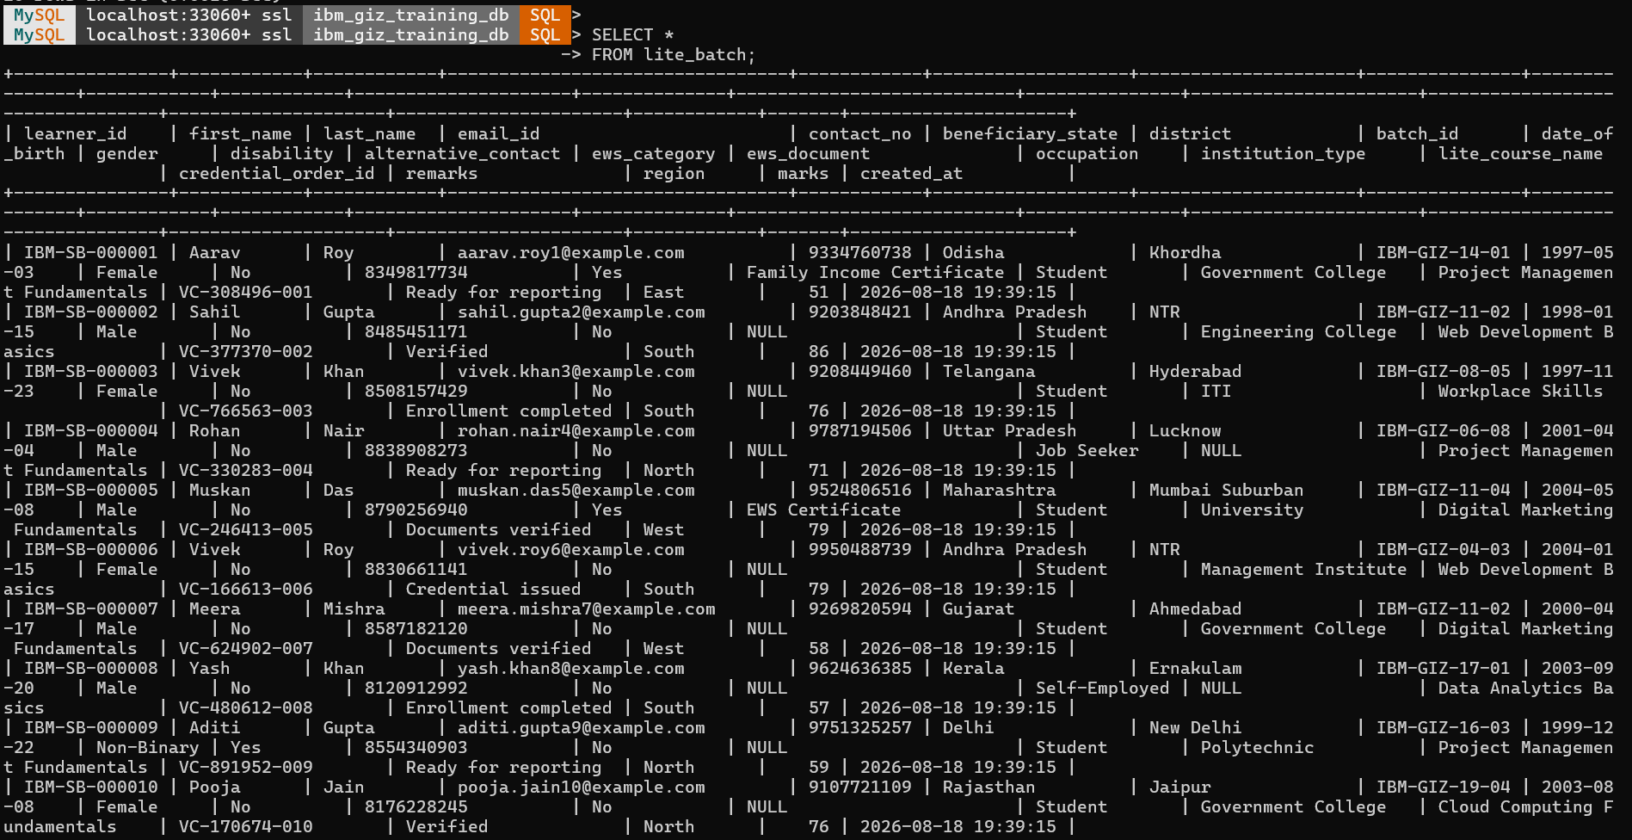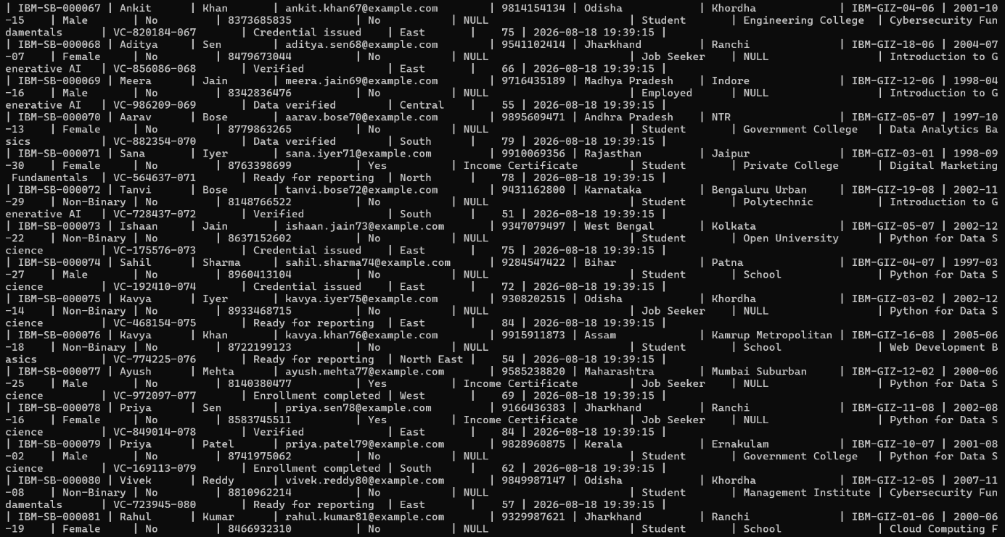

- SELECTING
learner_id, first_name,last_name,email_id,region,marks
FROM lite_batch

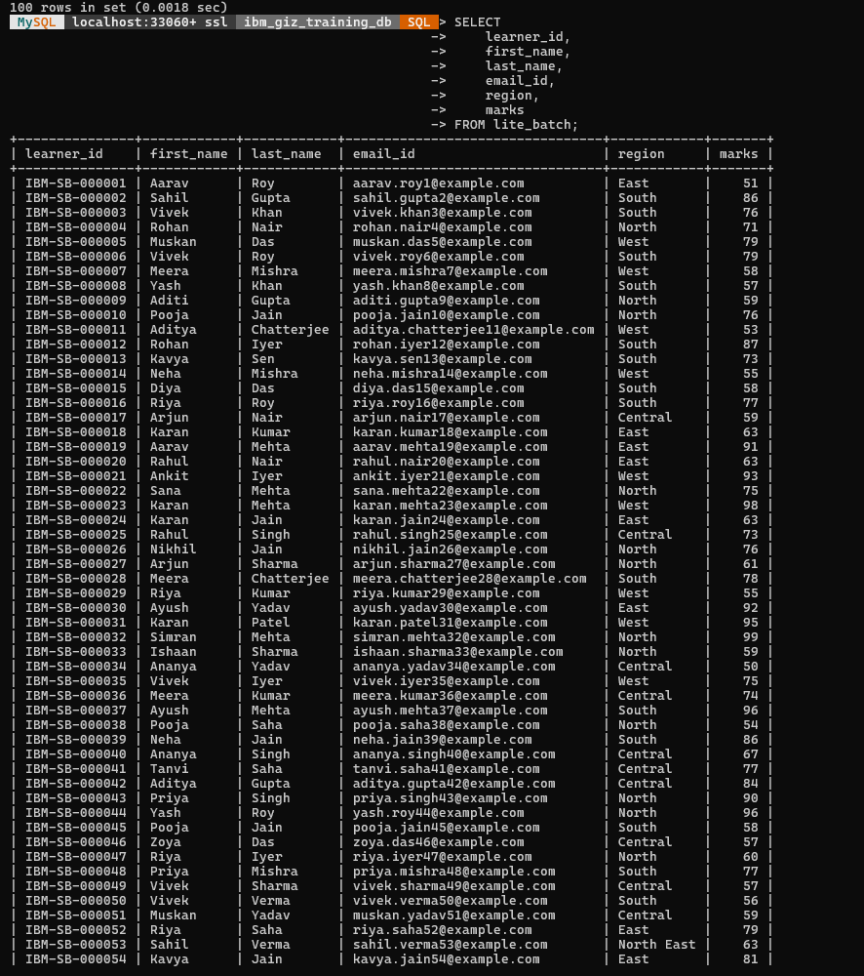
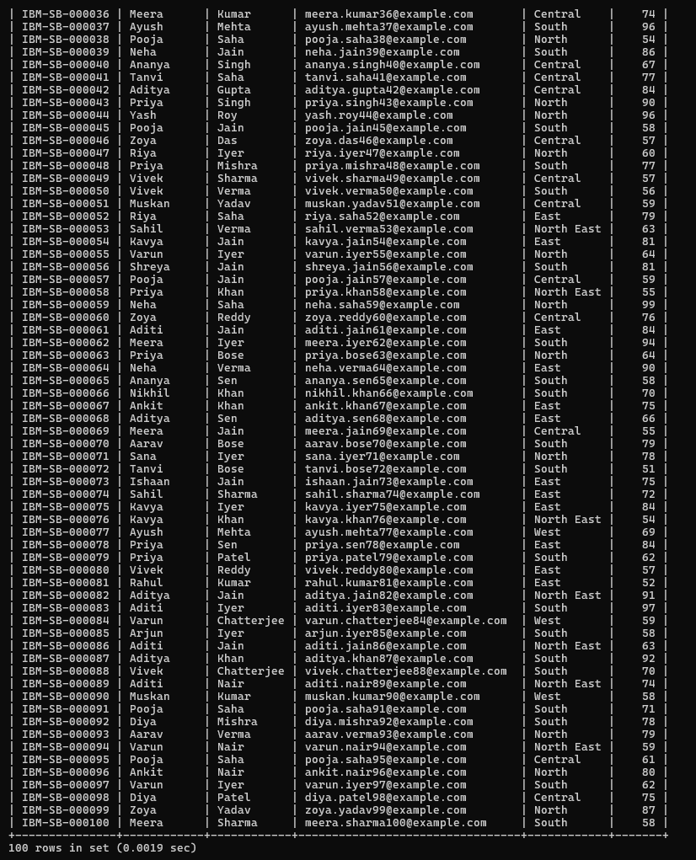
2. WHERE:
Learners with marks above 75.

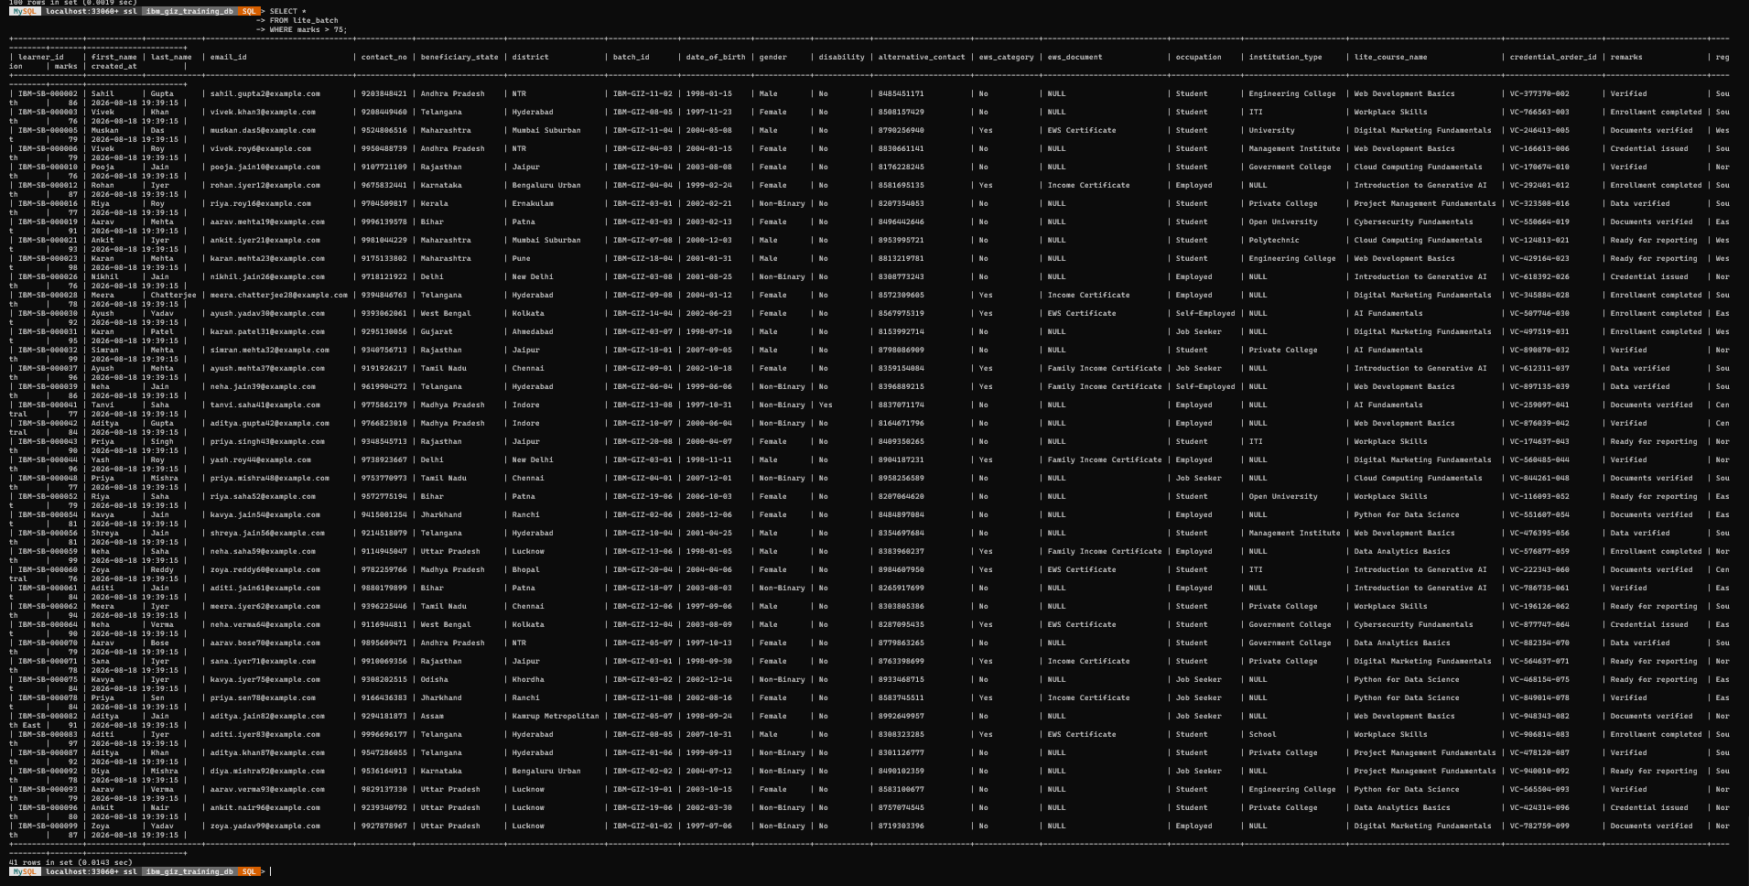
-- Learners from a particular region
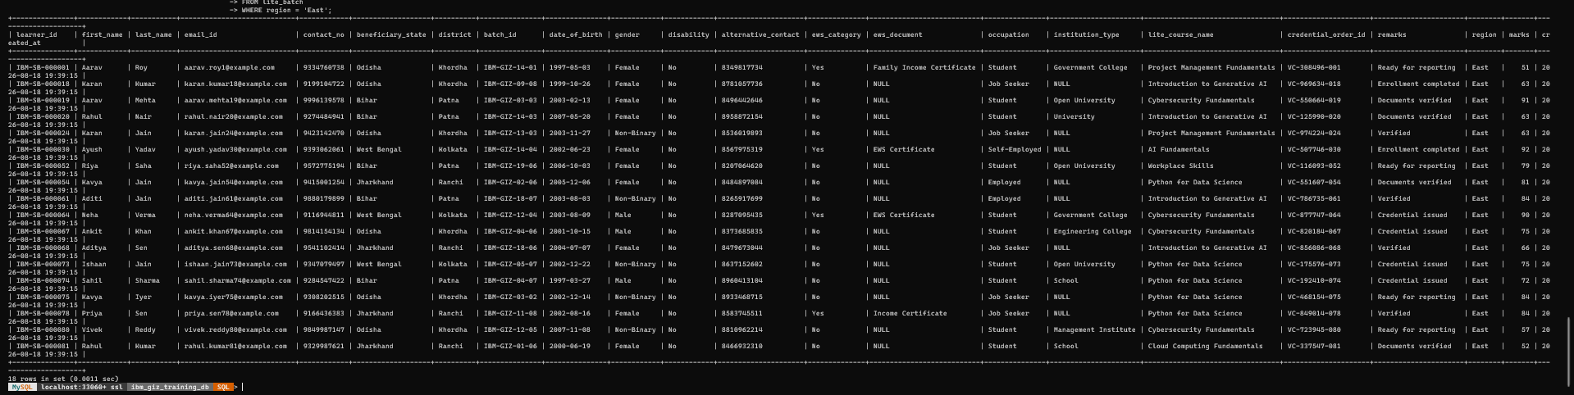
-- Multiple conditions
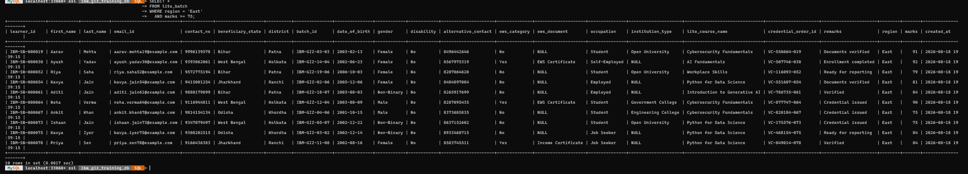
-- OR OPERATION
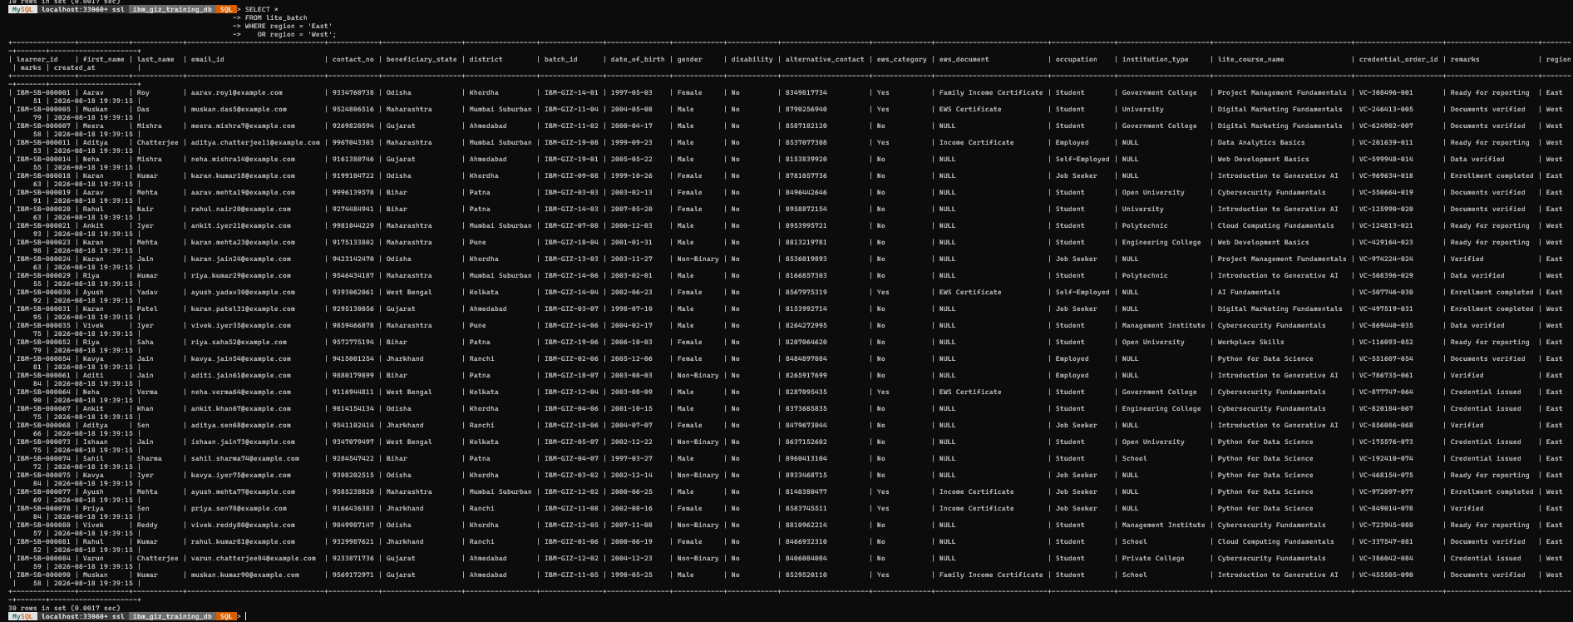
3. BETWEEN:
-- Learners whose marks are between 70 and 85
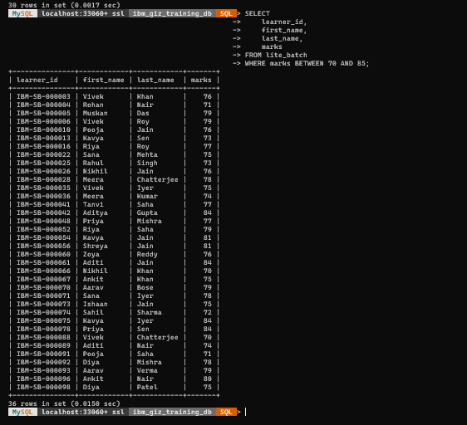
4. IN:
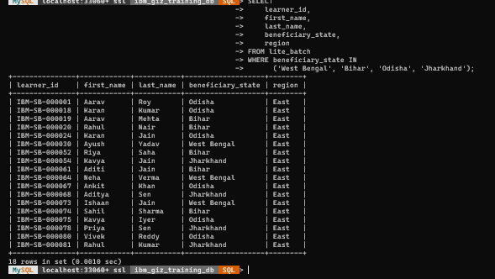
5. LIKE:
-- First names beginning with A
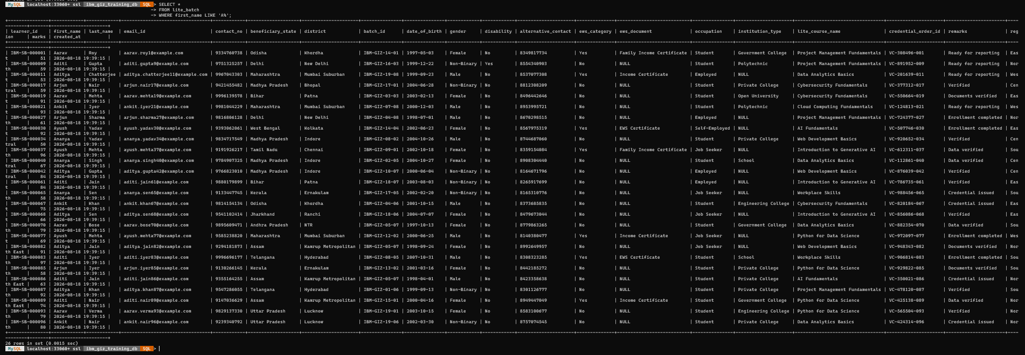
-- First names ending with a
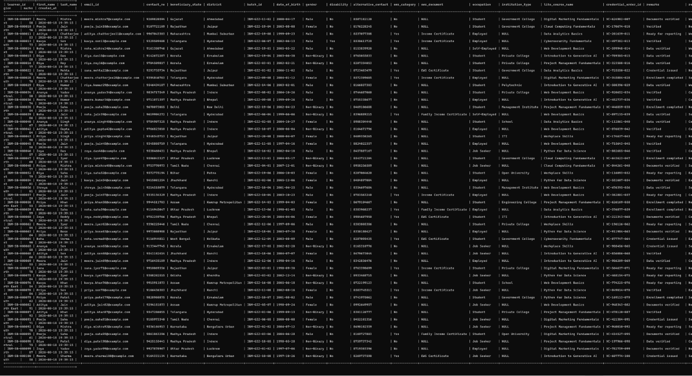
-- Names containing "an"
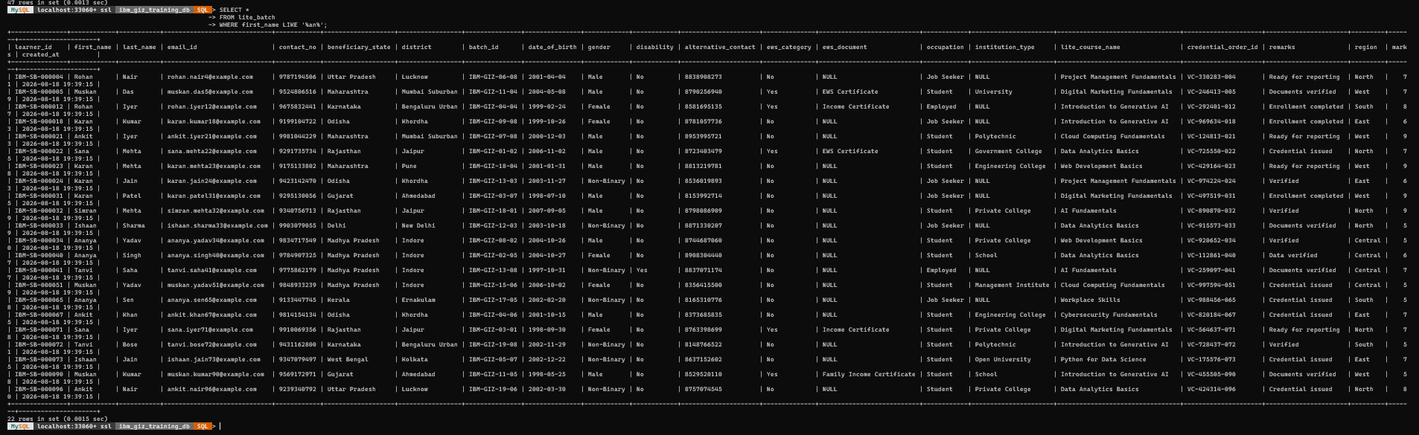
6. ORDER BY:
-- Highest marks first
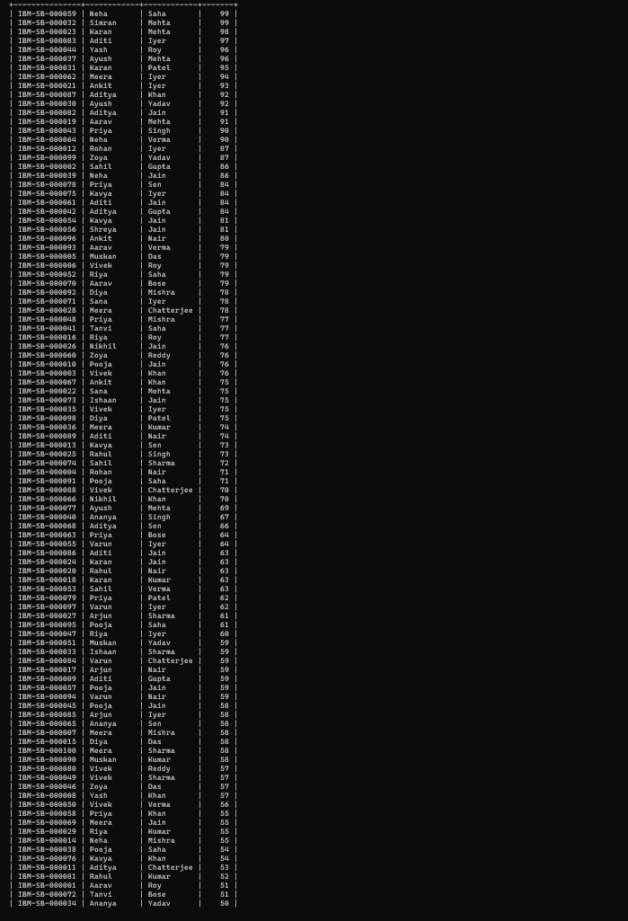

-- Sort by region, then marks
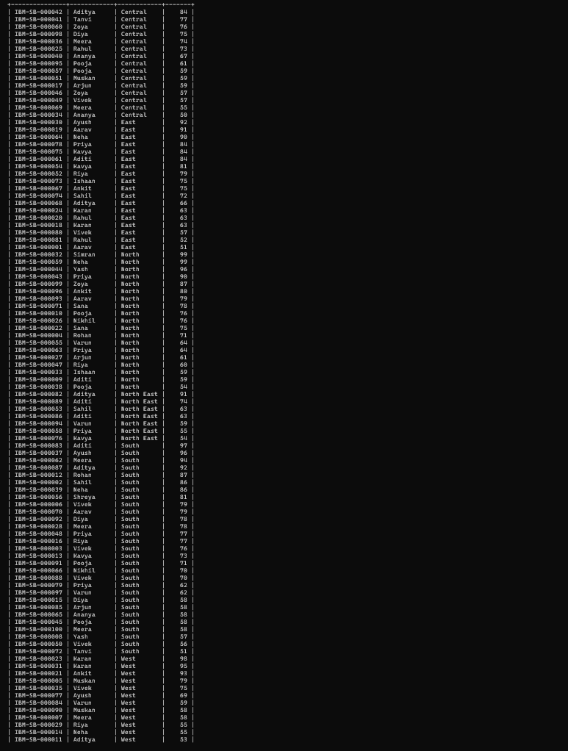

7. LIMIT:
-- Top 3 learners by marks
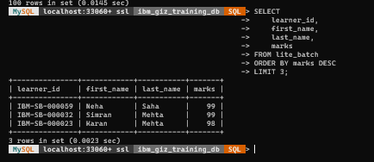
8. DISTINCT BY REGION:
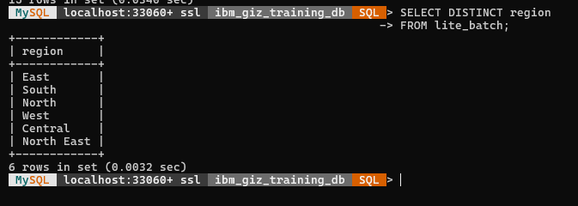
9. UPDATE
-- Safe demonstration: change a value and immediately restore it.
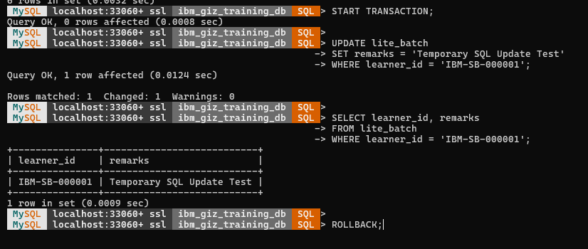
10. DELETE
-- Safe demonstration using a non-existent test ID.
-- No real learner is deleted.
11. INNER JOIN
-- LITE learners who are also present in LITE/DEEP.
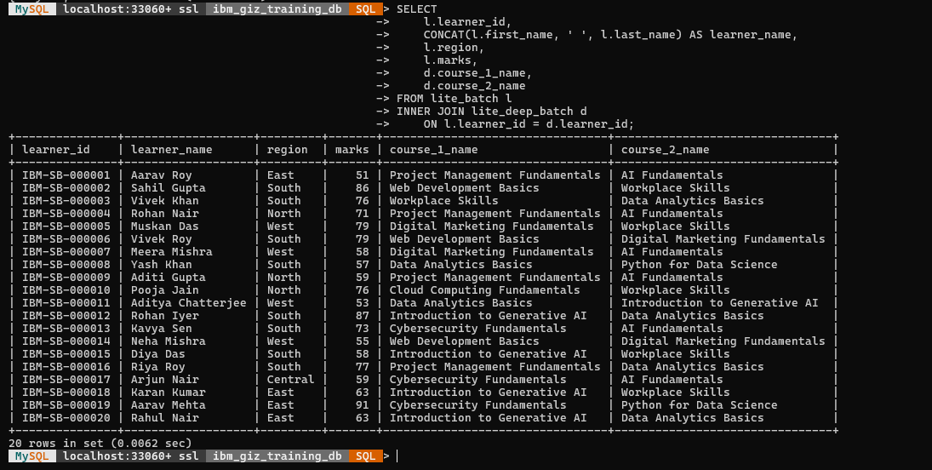
12. LEFT JOIN
-- All LITE learners, including those not in LITE/DEEP.
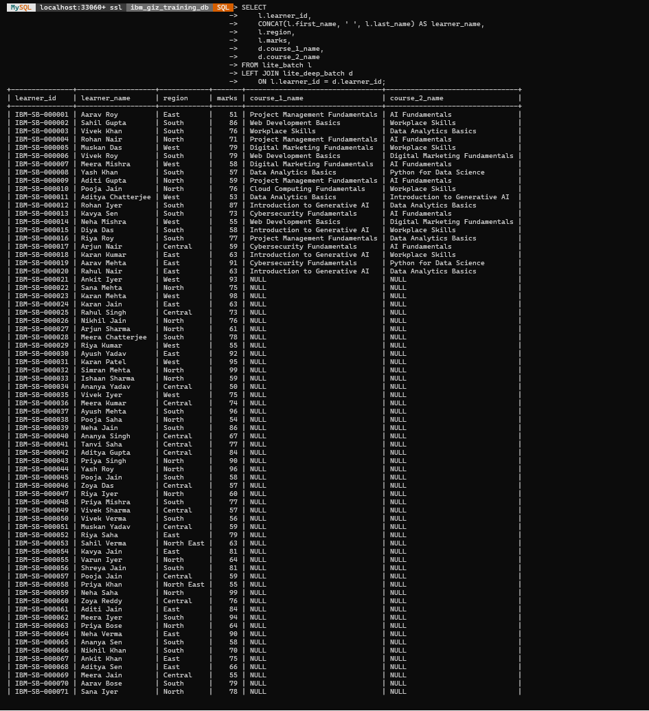
13. COUNT:
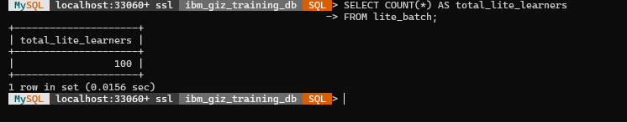
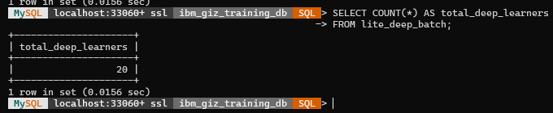
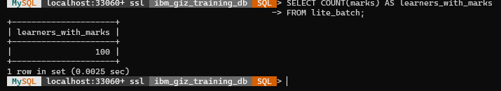
14. SUM:
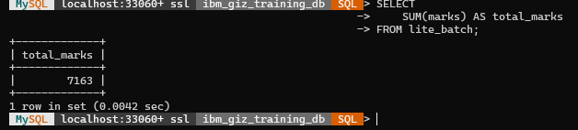
15. AVG:
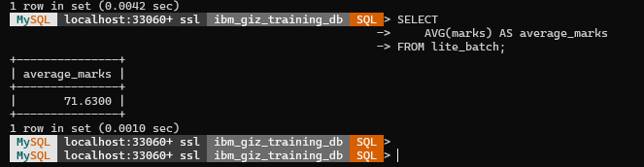

16. MIN AND MAX:
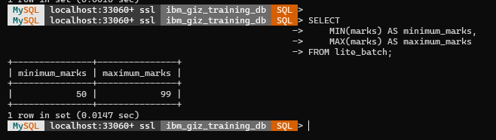
17. GROUP BY:
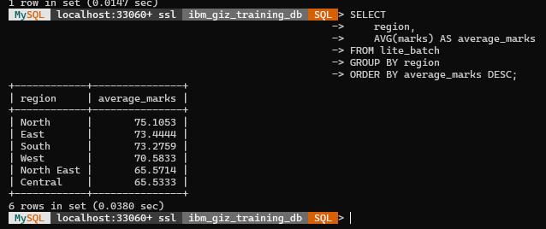
18. HAVING
-- Filter groups after GROUP BY:
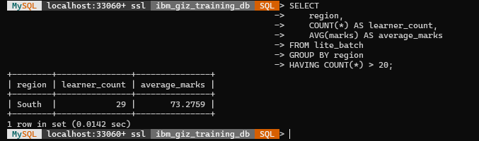

19. CASE EXPRESSION
-- Performance classification based on marks:
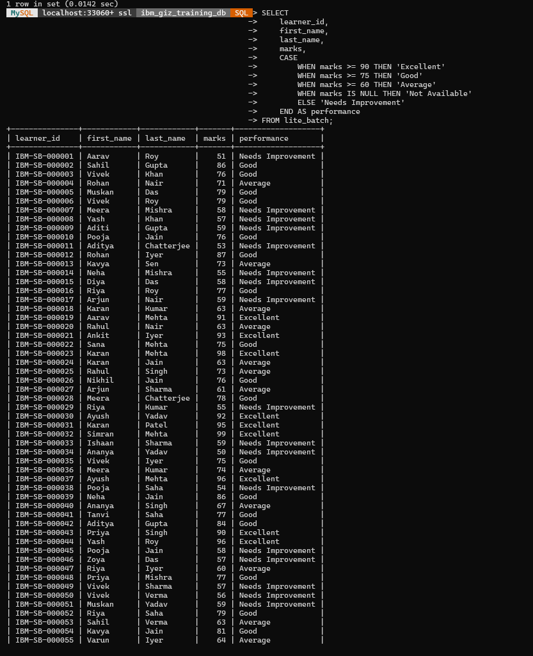
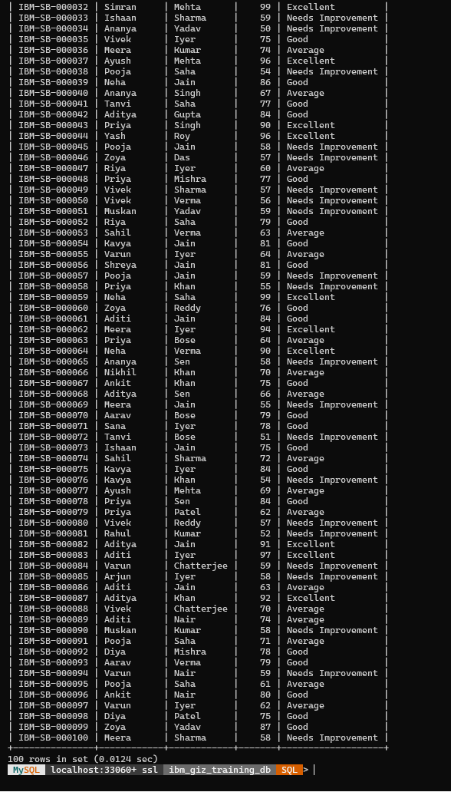
20. NULL HANDLING:
-- Course 3 is intentionally blank for the DEEP subset.
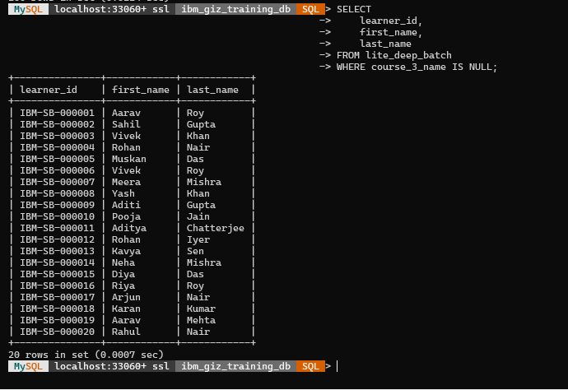
-- Learners without an EWS document
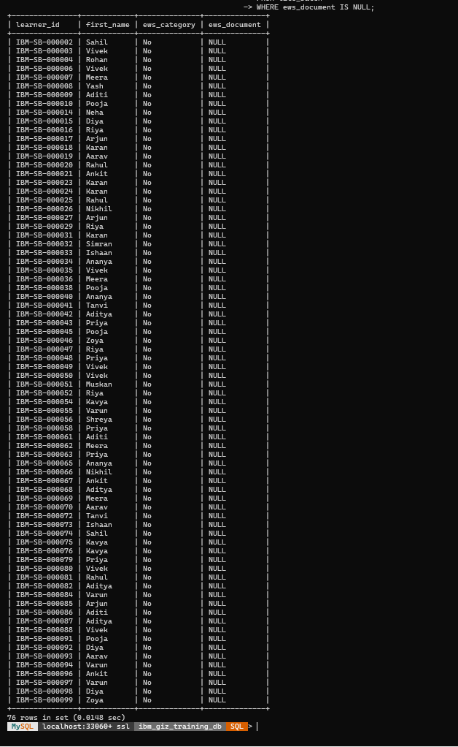
21. SUBQUERY
-- Learners scoring above the overall average:
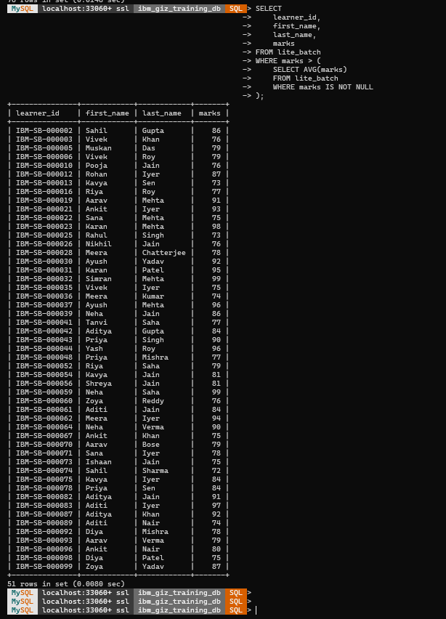
22. SECOND-HIGHEST MARKS: 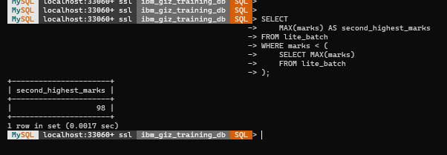
23. TOP 3 MARKS USING DENSE_RANK:
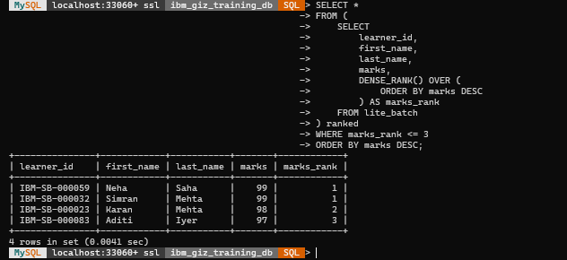
24. PARTITION BY
-- Rank learners within each region:
